1. Coal is mines in Collie, in the south-west of Western Australia. The coalfield was discovered in 1880’s, and mining began in the 1890s.
2. What are two **geophysical** methods of exploration that could be used to discover a new coal resource? (10 marks total)

For each of these:

1. State and describe the method (3 marks)
2. Provide evidence that might indicate that coal was present. (2 marks)

Feel free to use a diagram to support your answer.

Method one: ________________________________________________________________

Description of method: ________________________________________________________

___________________________________________________________________________

___________________________________________________________________________

___________________________________________________________________________

Evidence of coal: _____________________________________________________________

___________________________________________________________________________

___________________________________________________________________________

___________________________________________________________________________

Method two: ________________________________________________________________

Description of method: ________________________________________________________

___________________________________________________________________________

___________________________________________________________________________

___________________________________________________________________________

Evidence of coal: _____________________________________________________________

___________________________________________________________________________

___________________________________________________________________________

___________________________________________________________________________

1. Explain why using a magnetic survey exploration method would **not** be suitable for identifying a coal resource. (3 marks)

___________________________________________________________________________

___________________________________________________________________________

___________________________________________________________________________

___________________________________________________________________________

___________________________________________________________________________

___________________________________________________________________________

1. Describe how you could use a **geochemical** samplingtechnique to identify a more precise location of the coal resource. (5 marks)

Feel free to use diagrams to support your answer

___________________________________________________________________________

___________________________________________________________________________

___________________________________________________________________________

___________________________________________________________________________

___________________________________________________________________________

___________________________________________________________________________

___________________________________________________________________________

___________________________________________________________________________

___________________________________________________________________________

___________________________________________________________________________

___________________________________________________________________________

___________________________________________________________________________

1. Describe the process of surface mining and when it is appropriate to use (4 marks)

___________________________________________________________________________

___________________________________________________________________________

___________________________________________________________________________

___________________________________________________________________________

___________________________________________________________________________

___________________________________________________________________________

1. Describe the process of underground mining and when it is appropriate to use (4 marks)

___________________________________________________________________________

___________________________________________________________________________

___________________________________________________________________________

___________________________________________________________________________

___________________________________________________________________________

___________________________________________________________________________

___________________________________________________________________________

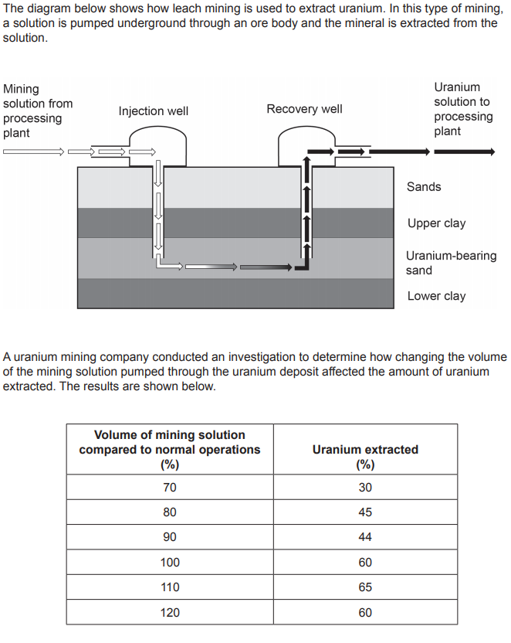

1. Identify the following variables for the investigation (4 marks)
2. Independent: _______________________________________________________
3. Dependent: ________________________________________________________
4. Two controlled variables: ______________________________________________
5. Draw a line graph of the results for this investigation (5 marks)



Using the data, **recommend** and **justify** the volume of mining solution that the company should use in order to extract the most uranium (2 marks)

___________________________________________________________________________

___________________________________________________________________________

___________________________________________________________________________